AMini Project Report

On

**ARINFOCRAFT**

*Submitted in partial fulfillment of the requirements for the award of the degree of*

**BACHELOR OF** **TECHNOLOGY**

IN

**COMPUTER SCIENCE AND ENGINEERING**

**BY**

**Ms. C. PRAVALIKA (14N81A0514)**

**Ms. K. RASAGNA (14N81A0532)**

**Mr. M. ABHISHEK(14N81A0549)**

Under the guidance of

**Mr. K. PAVAN KUMAR**

**ASSISTANT PROFESSOR**

DEPARTMENT OF COMPUTER SCIENCE AND ENGINEERING



**Department of Computer Science and Engineering**

**Sphoorthy Engineering College**

**Naderagul (Vill.), Sagar Road, Near Vanasthalipuram, Saroornagar (Mdl.), R. R. Dist., Telangana. – 501510**

**2014-2018**

**DECLARATION**

We, the undersigned, declare that the project title “**ARINFOCRAFT**” carried out at “SPHOORTHY ENGINEERING COLLEGE” is original and is being submitted to the Department of COMPUTER SCIENCE AND ENGINEERING, Sphoorthy Engineering College, Hyderabad towards partial fulfillment for the award of Bachelor of Technology.

We, declare that, the result embodied in the Project work has not been submitted to any other University or Institute for the award of any Degree or Diploma.

**Date: K. RASAGNA**

**Place: Hyderabad 14N81A0566**

**C. PRAVALIKA**

**14N81A0589**

**M. ABHISHEK**

**14N81A0549**



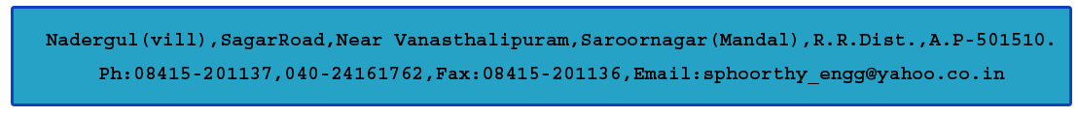

**DEPARTMENT OF COMPUTER SCIENCE AND ENGINEERING**

**CERTIFICATE**

This is to certify that project entitled “**ARINFOCRAFT”** is a bonafide work carried out by Ms. RASAGNA (14N81A0566), Ms. C. PRAVALIKA (14N81A0589), Mr. M. ABHISHEK (14N81A0591), in partial fulfillment for the award of Bachelor of Technology in Computer Science and Engineering, Sphoorthy Engineering College, Hyderabad during the year 2015-2016 under my supervision and guidance. The result embodied in the Project Work has not been submitted to any other University or Institute for the award of any Degree or Diploma.

**INTERNAL GUIDE HEAD OF DEPARTMENT**

**Mr. K. PAVAN KUMAR** **Mrs. J. DEEPTHI**

Assistant Professor Assistant Professor

**EXTERNAL EXAMINER**  **PRINCIPAL**

**DR. K.S. SHAJI**

**ACKNOWLEDGEMENT**

The completion of this project work gives us an opportunity to convey our gratitude to all those who have helped us to reach a stage where we have the confidence to launch our career in the competitive world in the field of Computer Science.

We would like to express our heartfelt thanks to **External Guide** forpermitting us to do a project work in their esteemed organization.

We express our sincere thanks to**,** **Dr. K. S. Shaji,** Principal, Sphoorthy Engineering College for providing all necessary facilities in completing our project report.

We express our sense of gratitude to **Prof**. **Mrs.** **J. Deepthi,** Head of Department of Computer Science and Engineering, who encouraged us to select the project and completion of this project with providing necessary facilities.

Our honest thankfulness **to** **Mr. K. PAVAN KUMAR**, (Internal Guide) for his kind help and for giving us the necessary guidance and valuable suggestions in completing this project work and in preparing this report.

We take the opportunity to express our gratitude to the Management, Teaching and Non-Teaching Staff of Sphoorthy Engineering College for their kind co-operation during the period of our Study.

Finally, we would like to thank our parents & friends for their continuous encouragement and support during the entire course of this project work.

**BATCH 2014 - 2018 K. RASAGNA**

**C. PRAVALIKA**

**M. ABHISHEK**

**CONTENTS**

1. ABSTRACT
2. INTRODUCTION
3. EXISTING SYSTEM
4. PROPOSED SYSTEM
5. LITERTURE SURVEY
6. SOFTWARE REQUIREMNETS
7. SOFTWARE REQUIREMENTS ANALYSIS  
     
    A) SOFTWARE INTRODUCTION.  
     
    B)SOFTWARE INSTALLATION.
8. SYSTEM DESIGN/UML DIAGRAMS
9. CODE TEMPLATES
10. OUTPUT SCREENS
11. ONLINE SOURCES

PAGE:5

**1.ABSTRACT**

Diabetes is one of the largest growing and has suffers of the disease where the patients of this disease weren’t allowed the sugar content much.

This project is used to solve their day- to – day problem where they can keep see the records of the content of the products they in the mall or general stores and finally get result to buy them or not. Moreover, this is implemented just by scanning the image of the product which can free the makers of the product from maintaining and implementing software’s which again need some other people to implement them.

In this project we use a Unity Engine to develop an android app where we intended to give some images which is used to identify some particular product and the identified product is being redirected to a browser where all the details of the product and decision to be taken or not is shown. This is made by connecting the phone to the internet and let the app be redirected to appropriate page. Hence here we used the Web Platform to complete the project

### 2.INTRODUCTION

The basic idea of “ArInfoCraft” is to let the diabetic patient to know whether to buy a product or not.

This is useful majorly to the diabetic patients as they can enjoy their products with lower content of the sugar and be protected with the harmful ones.

This is also useful to the normal people who intended to be diet and want to have lower sugar content in the products they buy.

This may not improve the health of the person but still suggests a person about the harmful ones and let them keep in a safe side of their health.

Moreover, the real meaning of our title “ArInfoCraft” means

AR- Augmented Reality

Info – Information

Craft- Crafting

Hence we intended to craft(develop) the information about the general products and help the diabetes people to get better products where we used AR platform (and also web) to do so.

**Project Summary:** Suggest a User that a given product is harmful or not on the basis of contents of the product they intended to buy

**1.1 EXISTING SYSTEM:**

There is various amount of the websites which always show us the contents of the products present. This is useful for some extent as some people may or may not identify the product has ‘high sugar content’. Thus these sites acts as the data part only.

**1.2 PROPOSED SYSTEM:**

In this project, we intended to scan the product by means of using AR technology which can relive us from the software for producing and maintaining the pictures and identifying the right one.

Then here we use the web platform to give access the information to the people easily and to everyone who has the internet.

Thus the app can help people to access the product (only One after the another) whereas the website can provide the lump of information where user has to find the product information he needs.

**ADVANTAGES OF PROPOSED SYSTEM:**

It takes less time for the user to get the details of the product as we don’t have any intermediate software sitting in the app we develop. Having the global access of information via maintaining a website for it.

**2.LITERATURE SURVEY**

According to the IDF, the [number of diabetics](https://www.diabetes.co.uk/diabetes-prevalence.html) in the world stands at 365 million people, representing around 8.5% of the global population. Today, there are 11 million Canadians living with diabetes or prediabetes

Most of the food we eat is turned into glucose, or sugar, for our bodies to use for energy. The pancreas, an organ that lies near the stomach, makes a hormone called insulin to help glucose get into the cells of our bodies.

When you have diabetes, your body either doesn't make enough [insulin](https://www.diabetes.co.uk/about-insulin.html) or can't use its own insulin as well as it should. This causes sugars to build up in the blood.

Diabetes can cause serious health complications including heart disease, blindness, foot problems, heart attack, stroke, anxiety, nerve damage, and erectile dysfunction (men), kidney failure, and lower-extremity amputations.

Diabetes-related complications can be very serious and even life-threatening. Properly managing blood sugar levels reduces the risk of developing these complications.

TYPES OF DIABETES:

Type 1 diabetes occurs when the immune system mistakenly attacks and kills the cells of the pancreas. Type 1 diabetes is always treated with insulin. Meal planning also helps with keeping blood sugar at the right levels.

Type 2 diabetes occurs when the body can’t properly use the insulin that is released (called insulin insensitivity) or does not make enough insulin. As aresult, sugar builds up in the blood instead of being used as energy. About 90 per cent of people with diabetes have type 2 diabetes. Type 2 diabetes more often develops in adults, but children can be affected.

A third type of diabetes, gestational diabetes, is a temporary condition that occurs during pregnancy. It affects approximately two to four per cent of all pregnancies

The main concern within the process designing the application is the access towards the different types of the information among various products but there is no application where they refine that information for sake of the diabetes. Hence we intended to refine the data present   for the general products that we buy in our date to date life and refine the information such that the product can be judged according to the basis of sugar levels so that the diabetes patients can but better product for protection of their health rather than searching the contents and confusing whether to buy a product or not. This can be done easily by just scanning the required product.

**CONCLUSION:** This project is to make a diabetic patient to scan a product and the tell whether the product is good enough for him or not.

**4. SOFTWARE REQUIREMENTS:**

|  |  |
| --- | --- |
| OPERATING SYSTEM | Windows 7 SP1+, 8, 10, 64-bit versions only; Mac OS X 10.9+.  Windows XP & Vista are not supported. |
| RAM REQUIRED | 2 GB of available disk space minimum, 4 GB Recommended (500 MB for IDE + 1.5 GB for Android SDK and emulator system image) |
| SOFTWARES USED | UNITY2017.3 , XAMPP OR WAMP,  VISUAL STUDIOS |
| ADDITIONAL REQUIREMENTS | Android: Android SDK and Java Development Kit8 (JDK). VISUAL STUDIOS WITH C++ COMPILER SUPPORT |
| LANGUAGES USED | C#, HTML. |

**5. SOFTWARE REQUIREMENT ANALYSIS**

1. INSTALLATION OF SOFTWARES.
   * 1. JAVA-JDK
     2. ANDROID-SDK
     3. XAMPP
     4. UNITY
2. CREATION OF UNITY APPLICATION
3. TRANSFORMING THE UNITY APPLICATION TO ANDROID.
4. CREATION OF WEB PAGES.
5. DEPLOYING OF WEBPAGES.

**5.1) Installing of the software’s:**

* 1. Java SDK

Download the required SDK according to the present platform where for sake of project we have used the version: Windows x64.

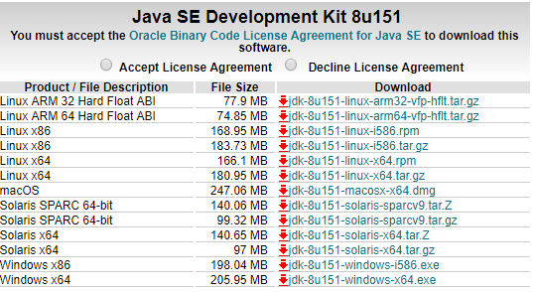

After completion of download, proceed the following steps to complete the installation.

1.Click on downloaded file to start the installation.

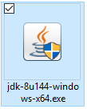

2.Now the .exe starts via showing the prompt screen.

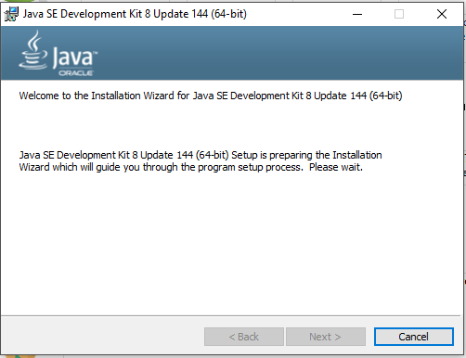

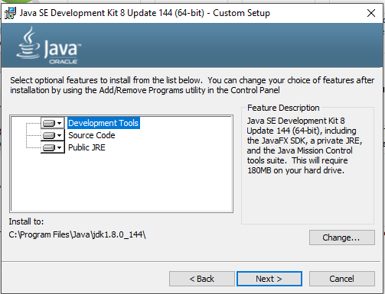

Here you can also change the path but we intended to remain the same. Now the installation starts

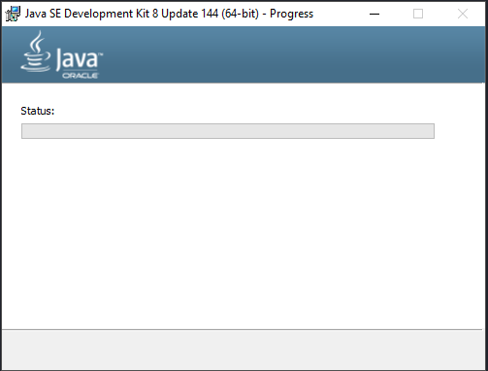

After completion of the setup installation following prompt can be seen.

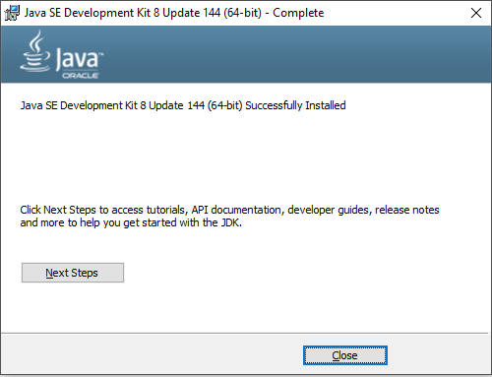

3.Adding the paths to the “Environment Variables”.

A)Go to java installation folder:

B)And select the path of java.exe.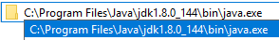

And copy the following path.

C)Then open the “ENVIRONMENT VARIABLES”

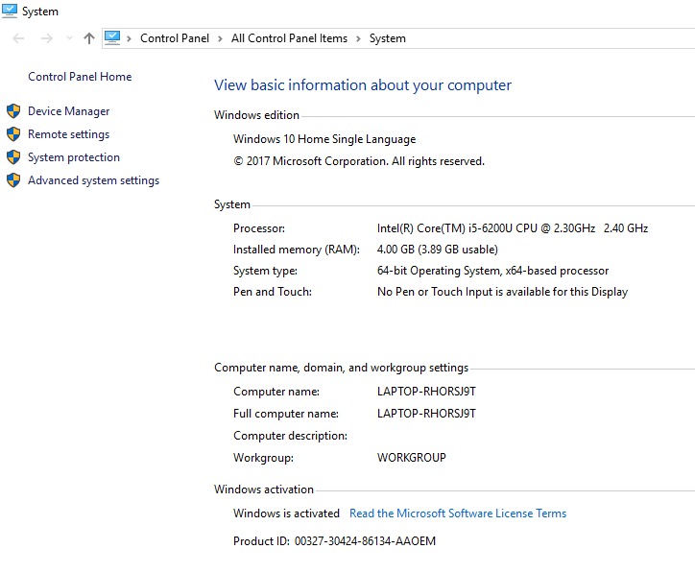

Then click on “Advanced System Settings” to open the following window.

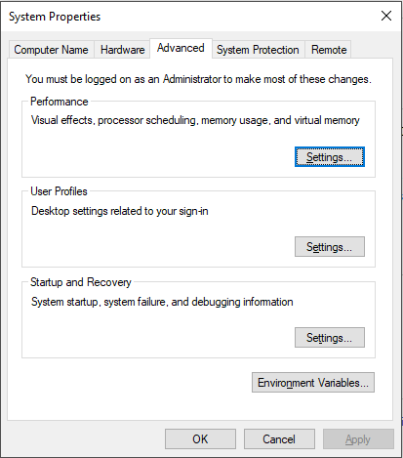

Click on ‘Environment Variables’ to see

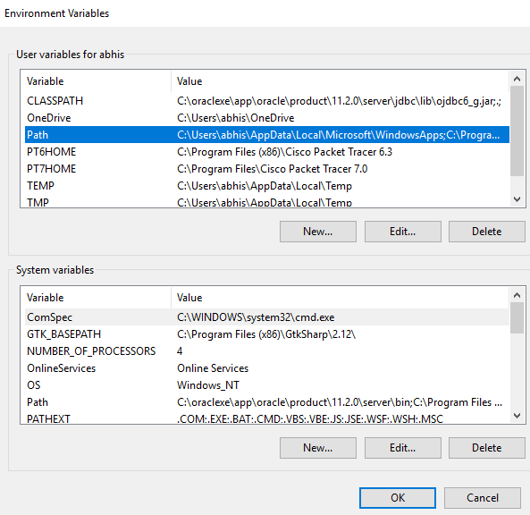

Click on ‘Path’ and then click on ‘Edit’ button. Here Click on ‘New’ and paste the copied path.

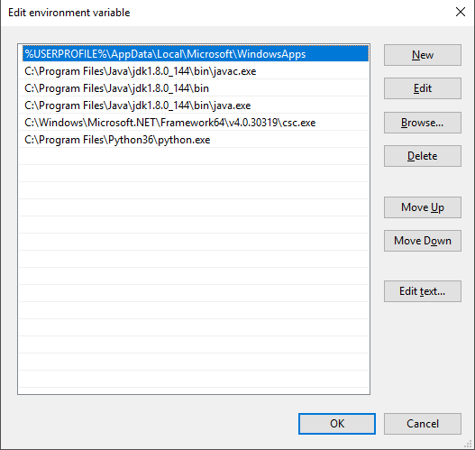

Do the same for ‘javac.exe’ and finally click on ‘Ok’.

Test the java is present in your path or not:

1. Press the windows key+R to open cmd , then type java

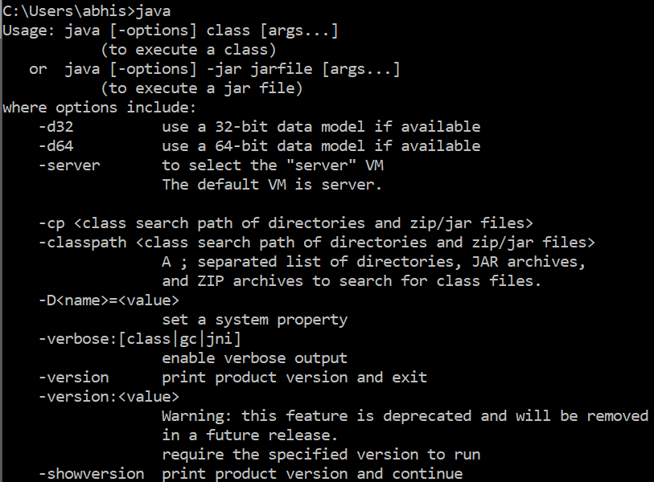

If this screen appears then java has set properly to path variable.Do the same by typing the ‘javac’ to check the javac path.

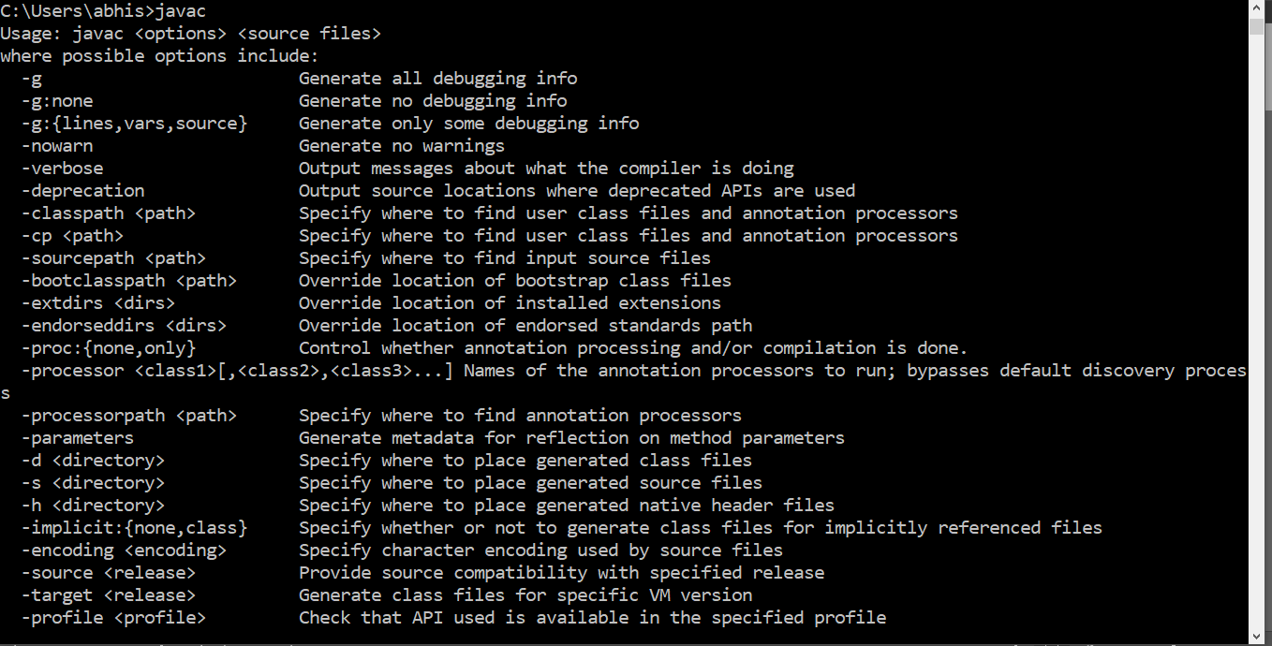

Hence this concludes the java installation.

* 1. Android-SDK:  
     Go to the official android website and download the required software from there. After downloading open the application by double clicking on  
     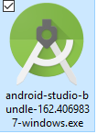  
     This runs our requires setup.  
      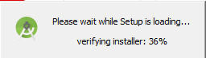  
     After completion of the loading os setup we can see installation setup  
     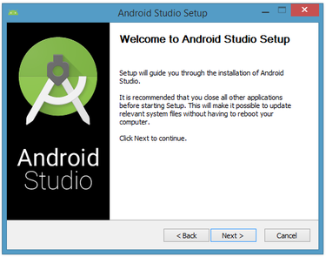  
     Click on ‘Next’  
       
       
     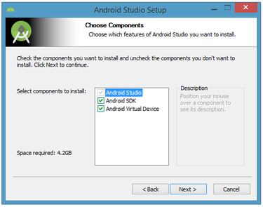  
     Choose the following components.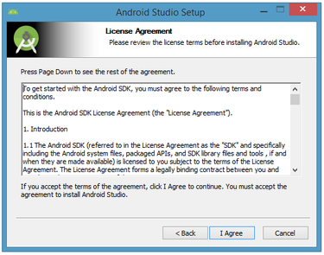  
     Click on ‘I Agree’  
     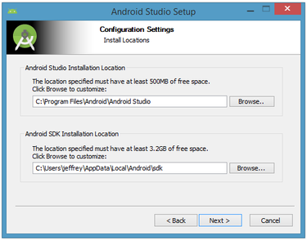  
     Click on ‘Next’  
     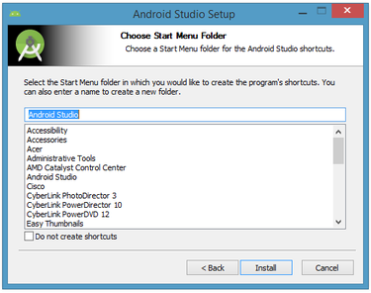  
     Click on ‘Next’  
     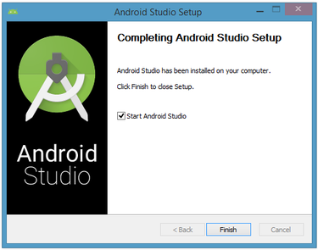  
     Click on ‘Finish’  
     This screen indicates the proper installation of android studio.  
     

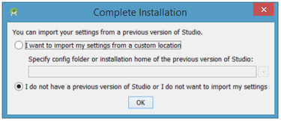  
Choose any one  
  
  
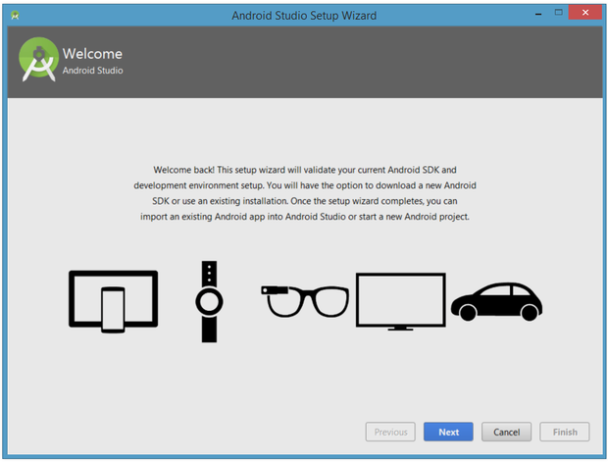click on ‘Next’  
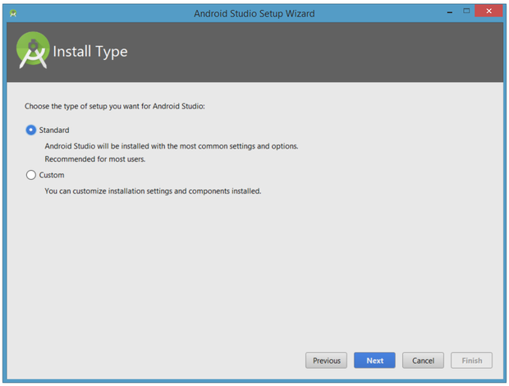  
Click on ‘Next’  
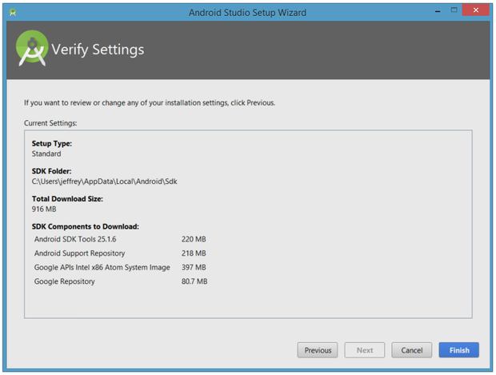  
click on ‘Finish’ to complete installation  
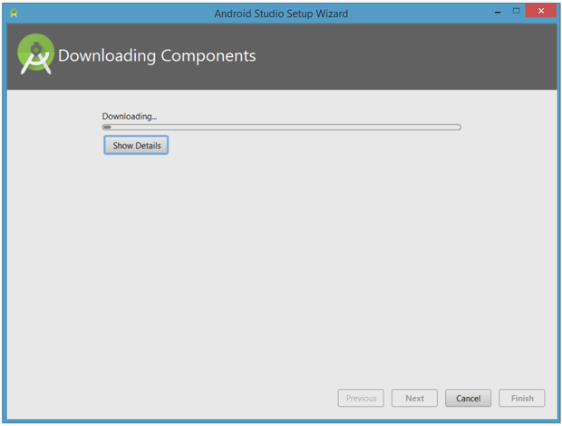  
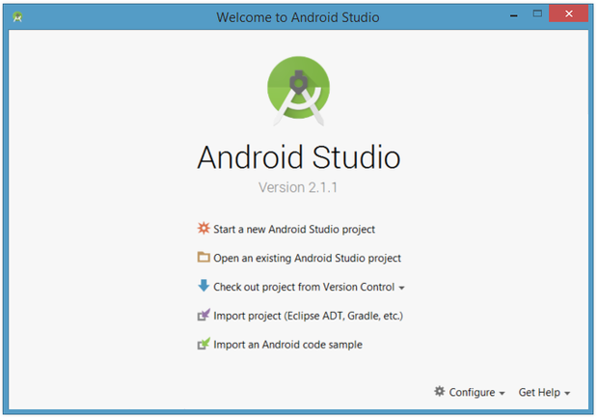  
This screen can verify the installation without any erros.

* 1. XAMPP  
     Go to the official xampp website (present in the references) and download the setup file.  
     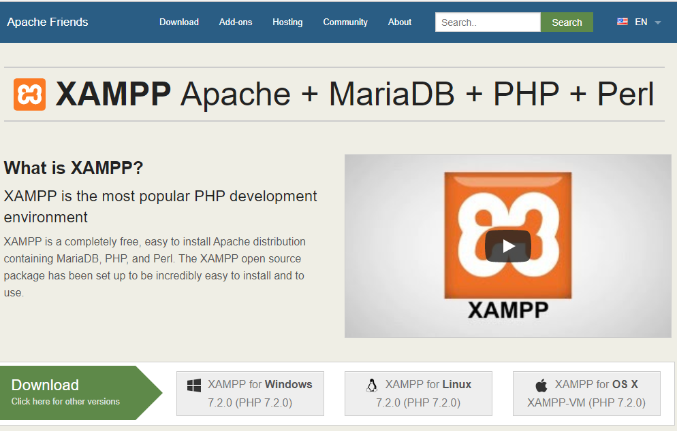  
     select the windows to download the setup file.  
     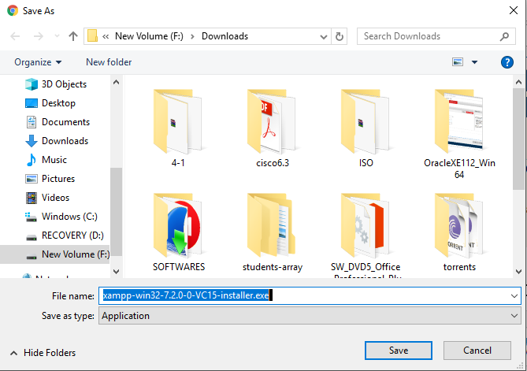  
       
       
     After Downloading ,Open the setup file.  
     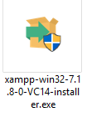  
     Which prompts.  
     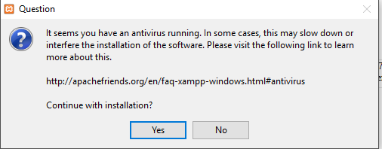  
     click on ‘Yes’.  
     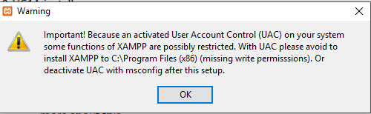  
     click on ‘Ok’  
     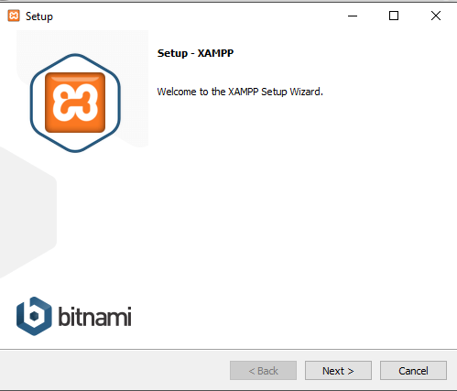  
     click on ‘Next’  
     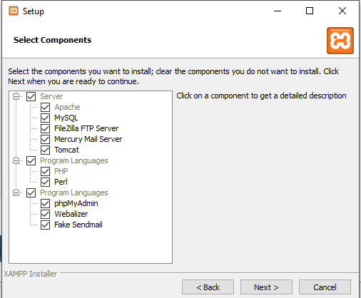  
     Select the components and click on ‘Next’.  
     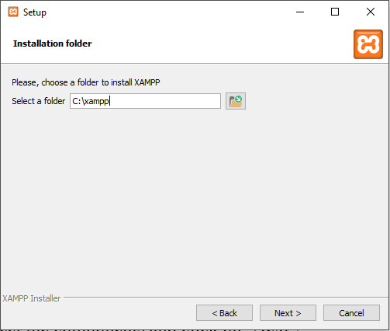  
     Let it be in the default path.After assigning proper folder it finally prompts to install or not, at that time simpy click on ‘Install’ and completion of installation we get.  
     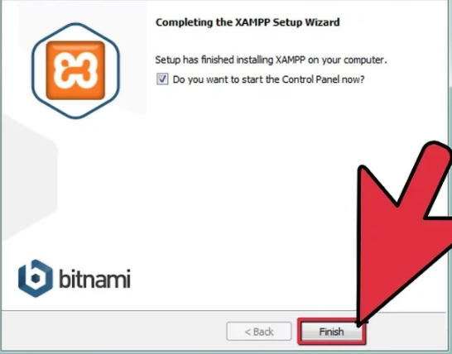  
     Click on “finish”  
       
     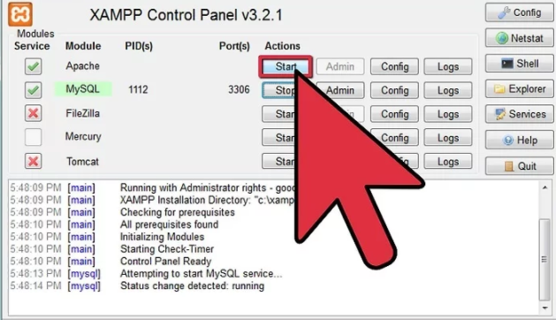  
     This screen indicates the proper running of the application.
  2. Unity:  
     go to the official unity website and download the ‘Free/personal’ installer to install the setup in the computer. Or you can directly visit the link from the Online Reference’s section.  
     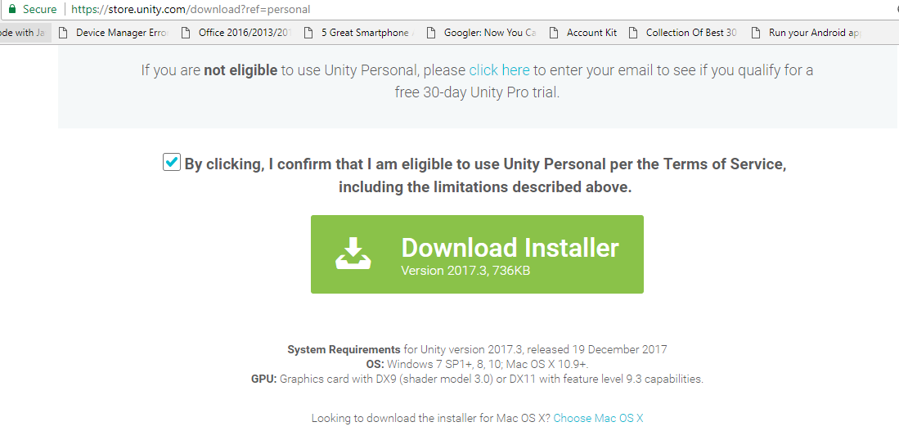  
     Thus click on the green button to get the installer.  
     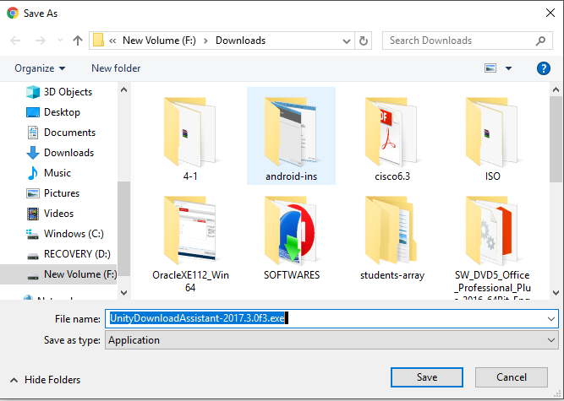  
     After completion of the download open the setup file.  
     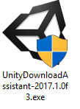  
     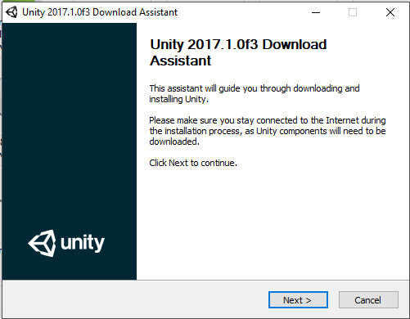  
     Click on ‘Next’  
     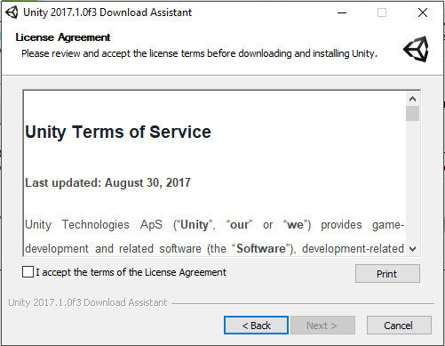  
     Select the checkbox and then click on ‘Next’  
     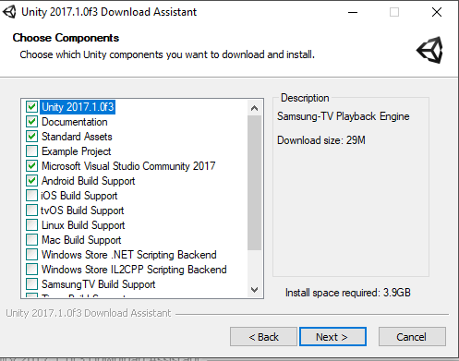  
     Select the required components from the list according to the needs.  
     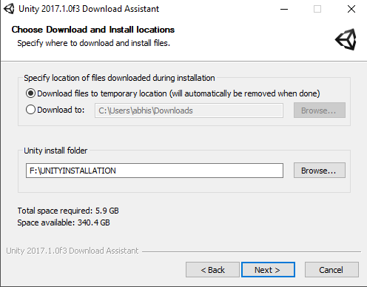  
     Choose path for installation of required files and unity application source folders and then click on ‘Next’.  
     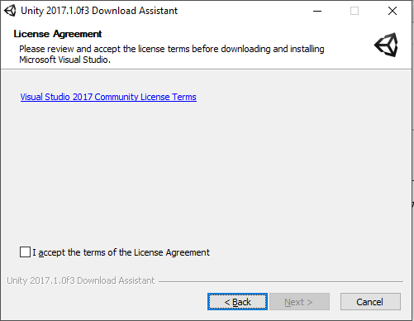  
     Accept the License Agreement and then click on ‘Next’.  
     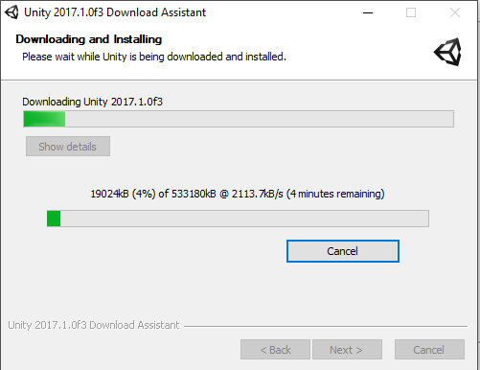  
     this will download the required files and store in the respective paths .  
     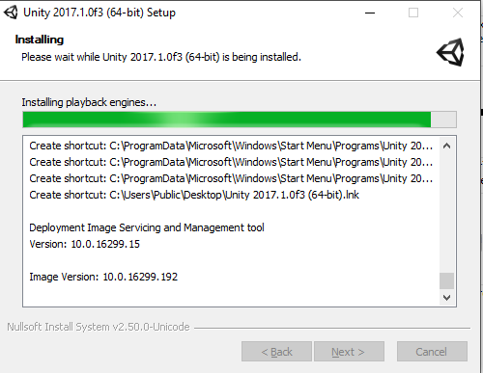  
     THE NEXT SCREENS SHOWS THE COMPLETION OF THE INSTALLAION SETUP.  
     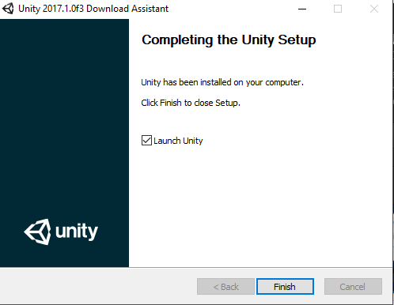  
     Click on ‘Finish’.  
     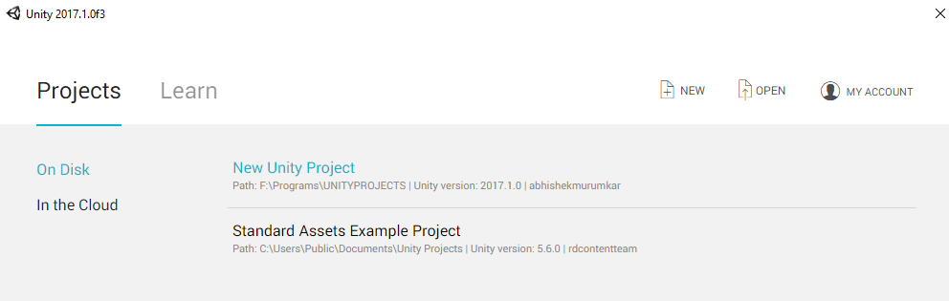  
     Click on ‘New’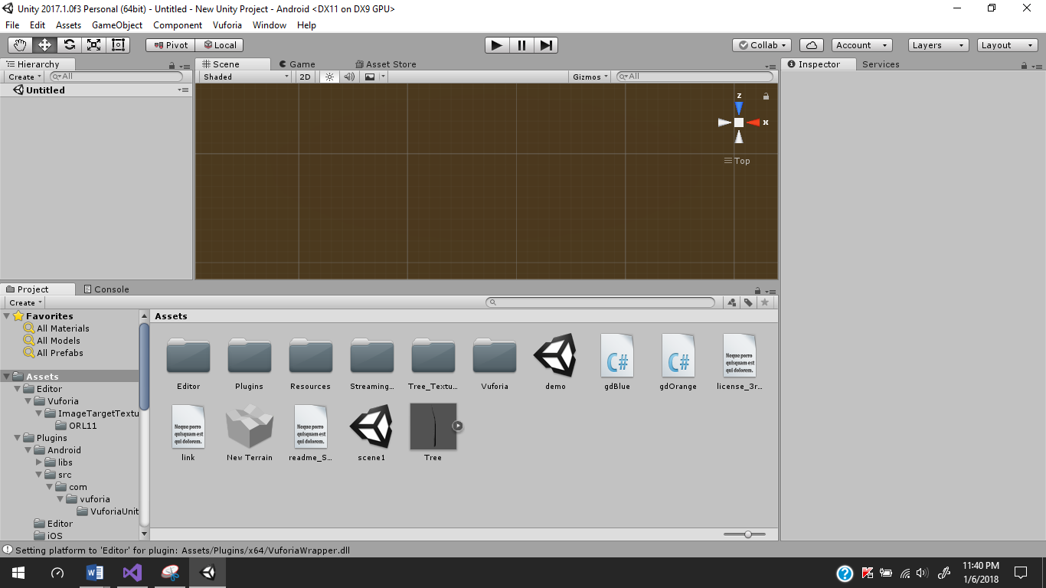

5.2) CREATION OF THE UNITY APPLICATION.

1)Vuforia Configuaration:

Go to the vuforia’s official website(from the link in the References) and sign in  
or sign up if you do not have the previous account in Vuforia.  
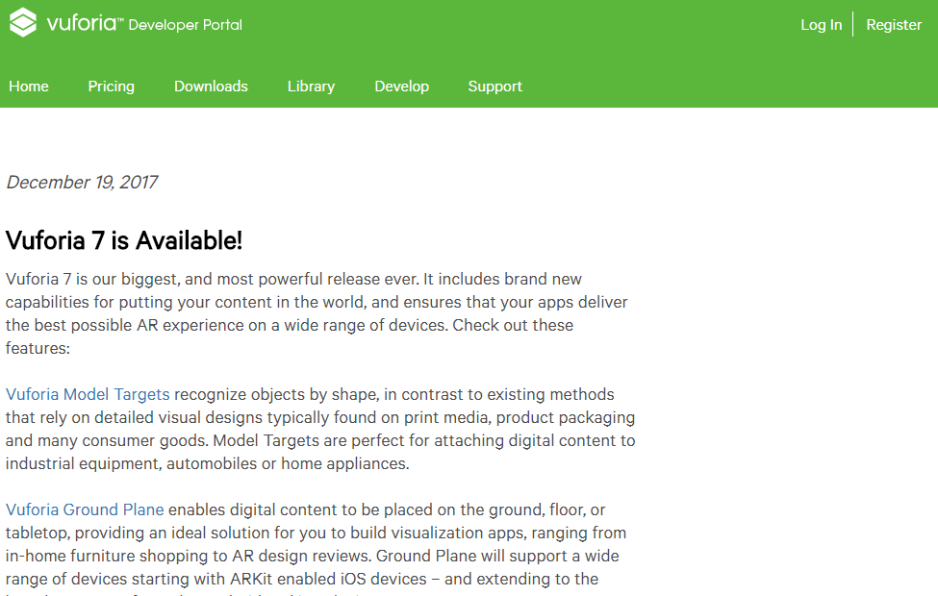  
The welcome screen of the Vuforia is  
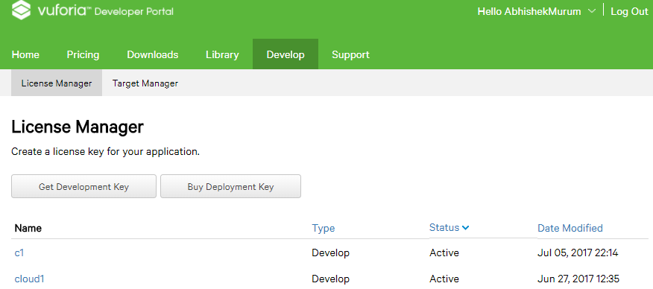  
  
Press on the ‘Get Development Key’ and fill the corresponding details.  
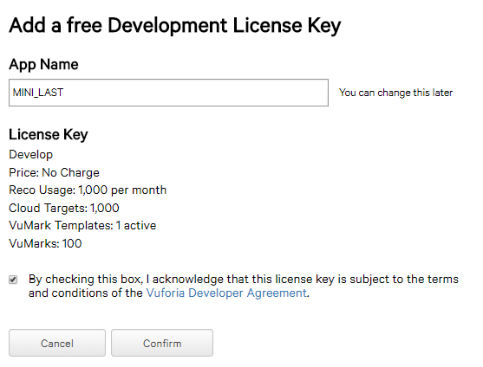  
and click on confirm  
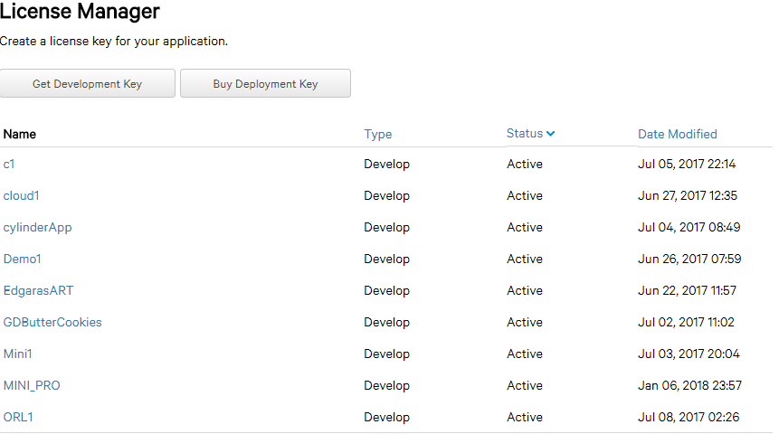  
this shows us the lists of application keys made by us.Hence click on our key ‘MINI_PRO’ which shows the License  
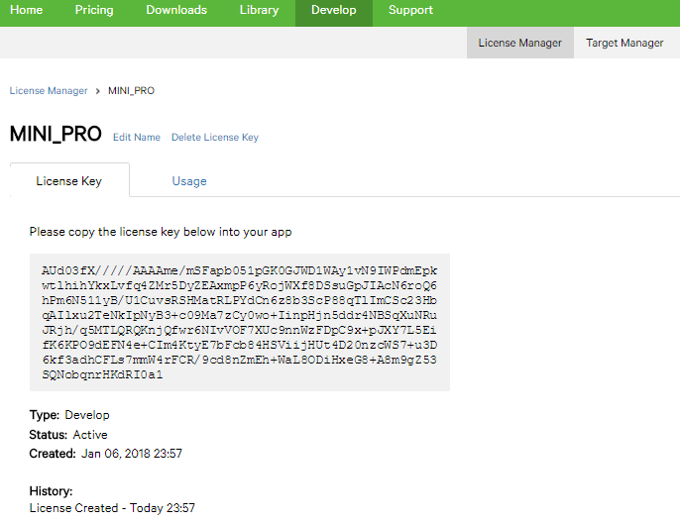  
Then move to the ‘Target Manager’ tab.  
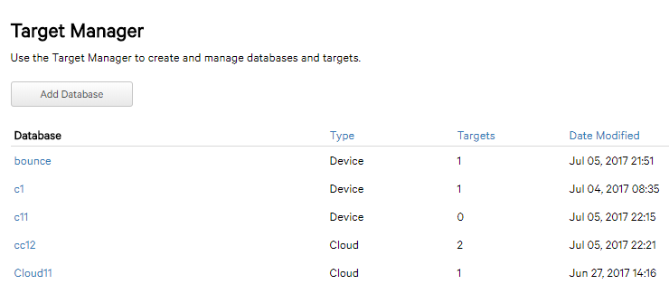  
To create new target click on ‘Add Database’. Then fill the appropriates and click on ‘create’.

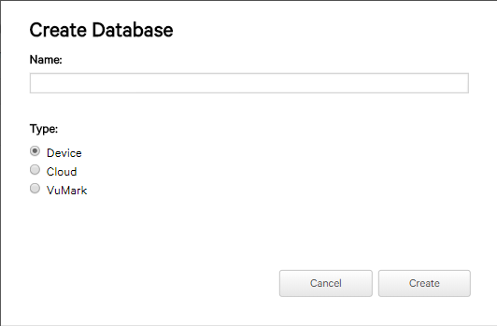 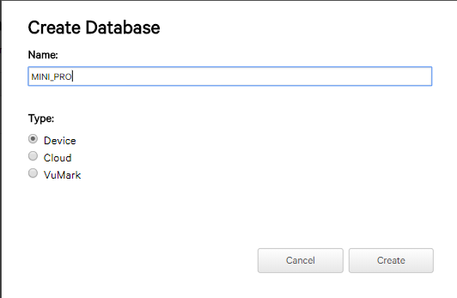  
Click on ‘MINI_PRO” to have ImageTargets as option  
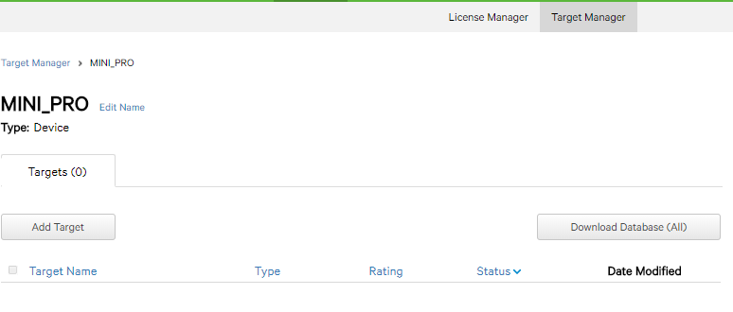  
where ‘Add Target’ lets to add our own image as Target.Click on ‘Add Target’   
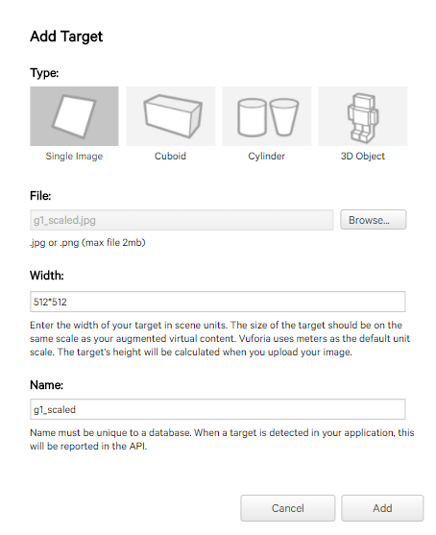  
After filling the appropriates click on ‘Add’.This will upload the target into cloud.  
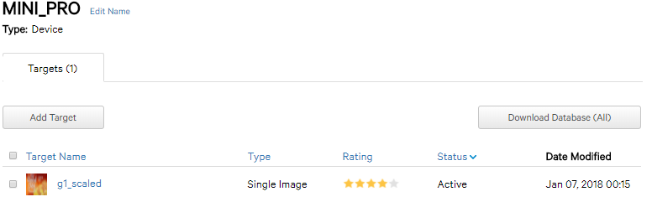  
Hence we see our target image.  
Now Click on ‘Download Database’ to obtain the Unity package of respective Image Target.

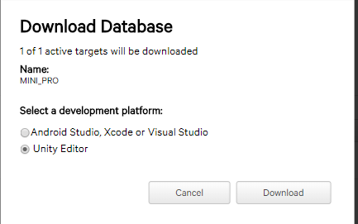  
Click on ‘Download’.  
  
click on ‘Save’  
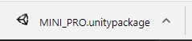

Click on the saved package to open in the unity editor.  
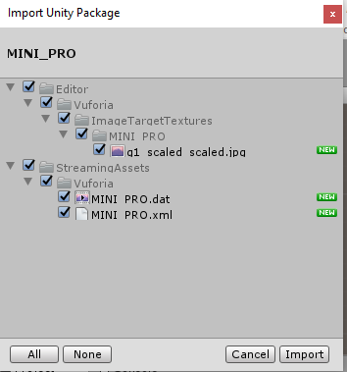  
Import Everything and click on ‘Import’

3)Setting a Response for the Image Target in the Unity  
go to.  
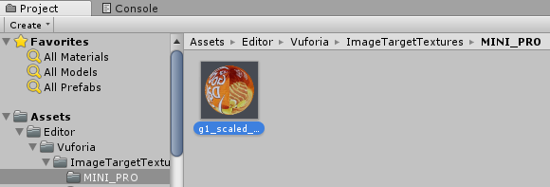  
on the right hand we can see  
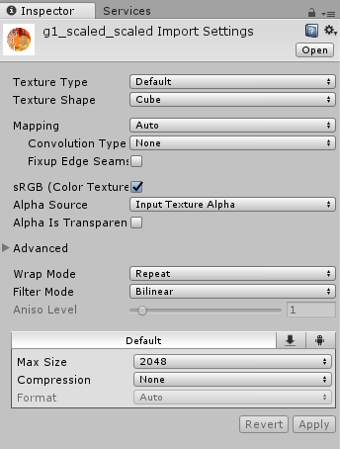  
Thus change the option ‘Cube’ as “2D” to render it as Image.  
Now go to Projects Tab and select the Vuforia folder  
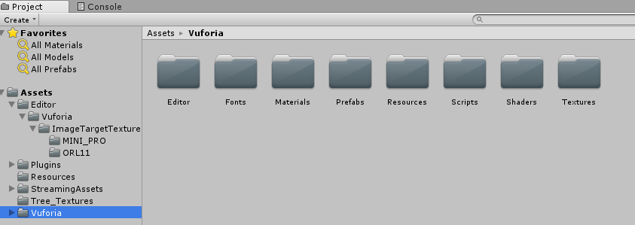  
Then Select the Prefabs  
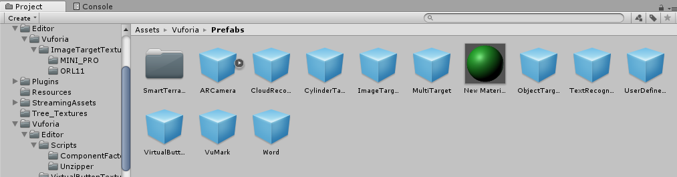  
Drag the ‘ImageTarget’ and drop in the Hierarchy plane.  
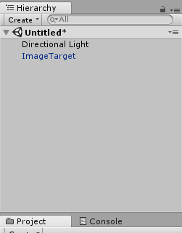  
Click on it to get into ‘Inspector’ tab.  
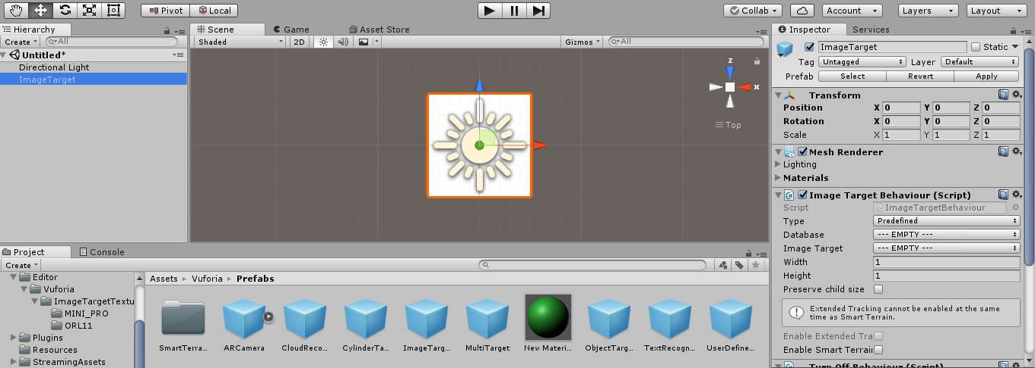  
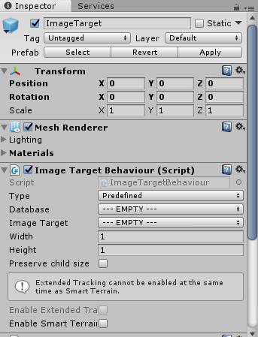  
Set the MINI_PRO option in the Database and choose the Image Target.  
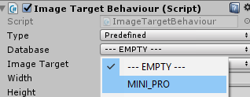  
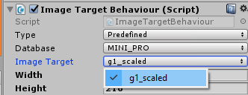  
This displays our Image Target.  
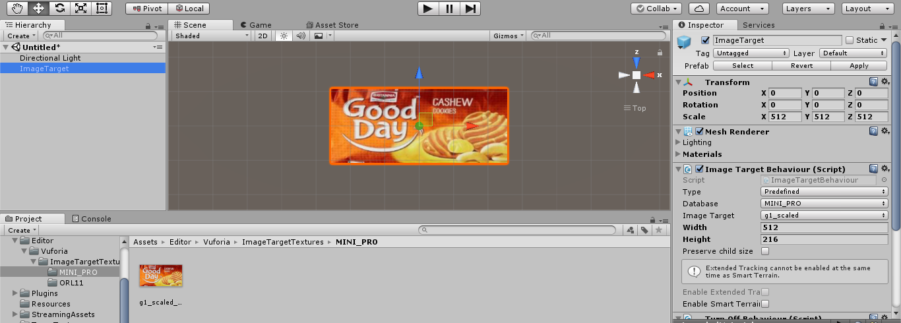  
Thus rename the Image Target as ‘actionButton’  
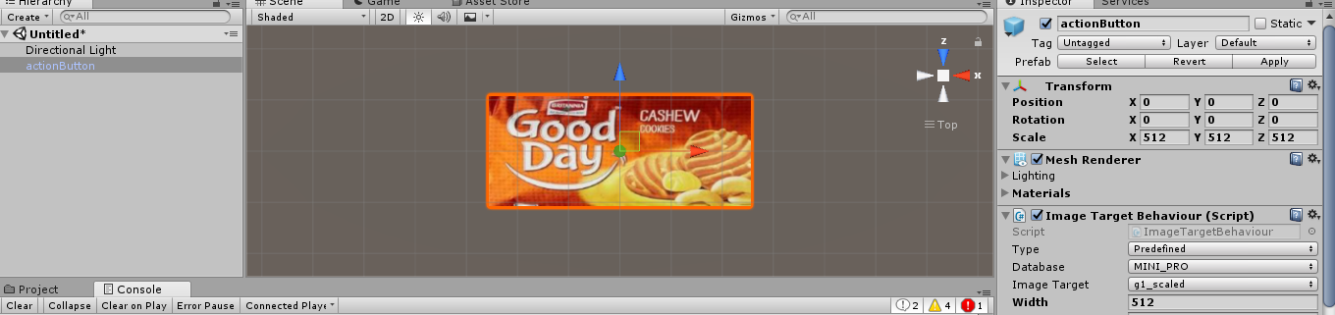  
Lets add a Virtual Button.This is done by dragging the ‘Virtual Button’ in the ‘Prefabs’ folder and dropping it on the ‘actionButton’. Renaming the button to ‘Action’.  
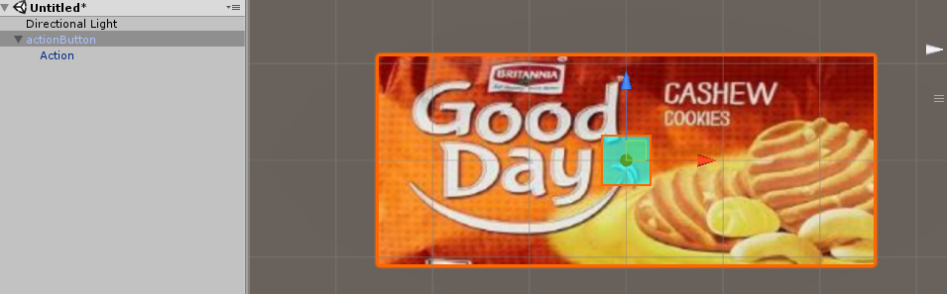  
the aqua colored square in the above image indicates the Virtual Button. Double click on the ‘Action’ and go to respective ‘Inspector’ Tab.  
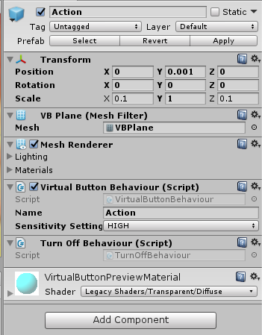   
Then click on ‘Add Component’  
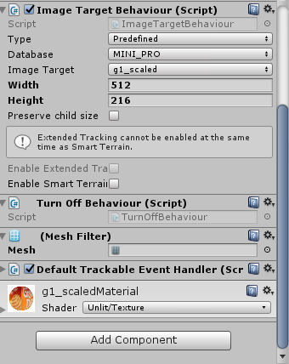  
And choose ‘New Script’  
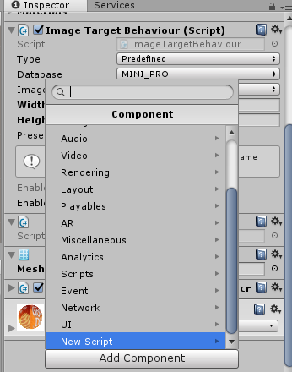  
Rename the ‘New Script’ to ‘Action’  
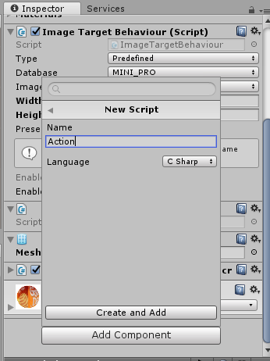  
click on ‘Create and Add’

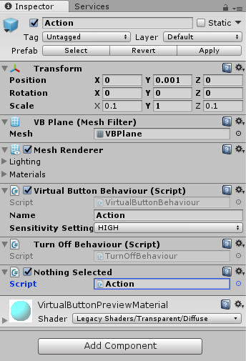  
Click on ‘Action’ to edit the script in the visual studios.  
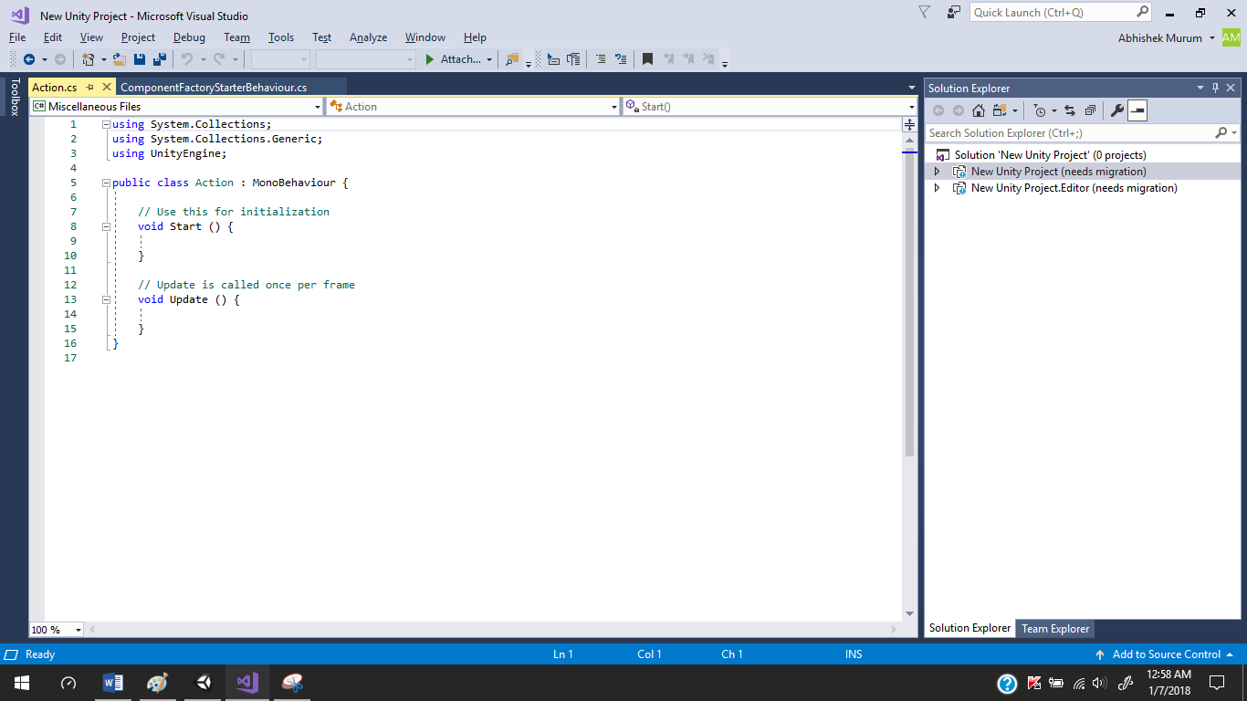  
Let us define require coding and close the file which will automatically compile the code and reports us the error. The code should be present here is given the ‘CODE’ Section of the Document. Hence Close the studios and edit the virtual button as  
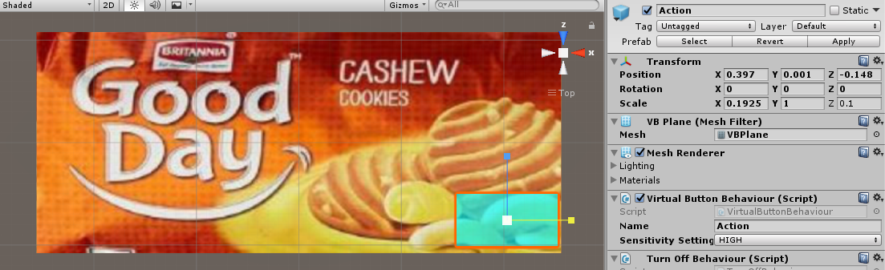  
Then move to the ‘Hierarchy’ Tab.  
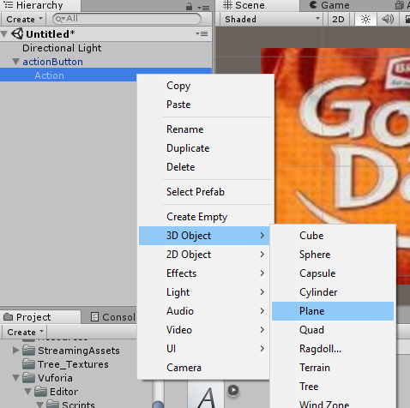  
This add a Plane in to our project.  
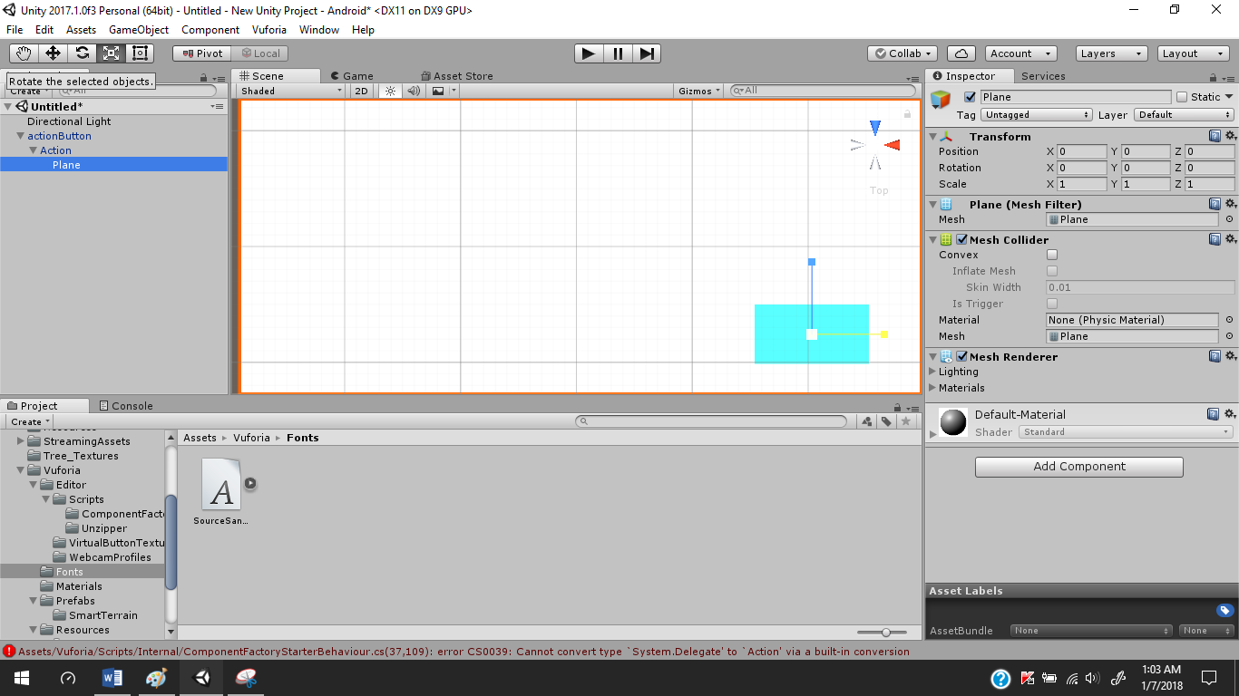  
edit the plane such that is present over the Virtual Button or Action.  
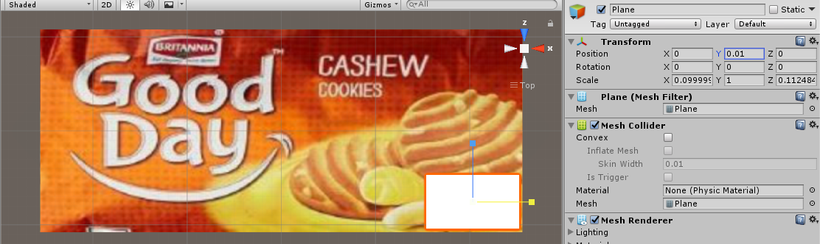  
Now Place Some Text on the Plane/  
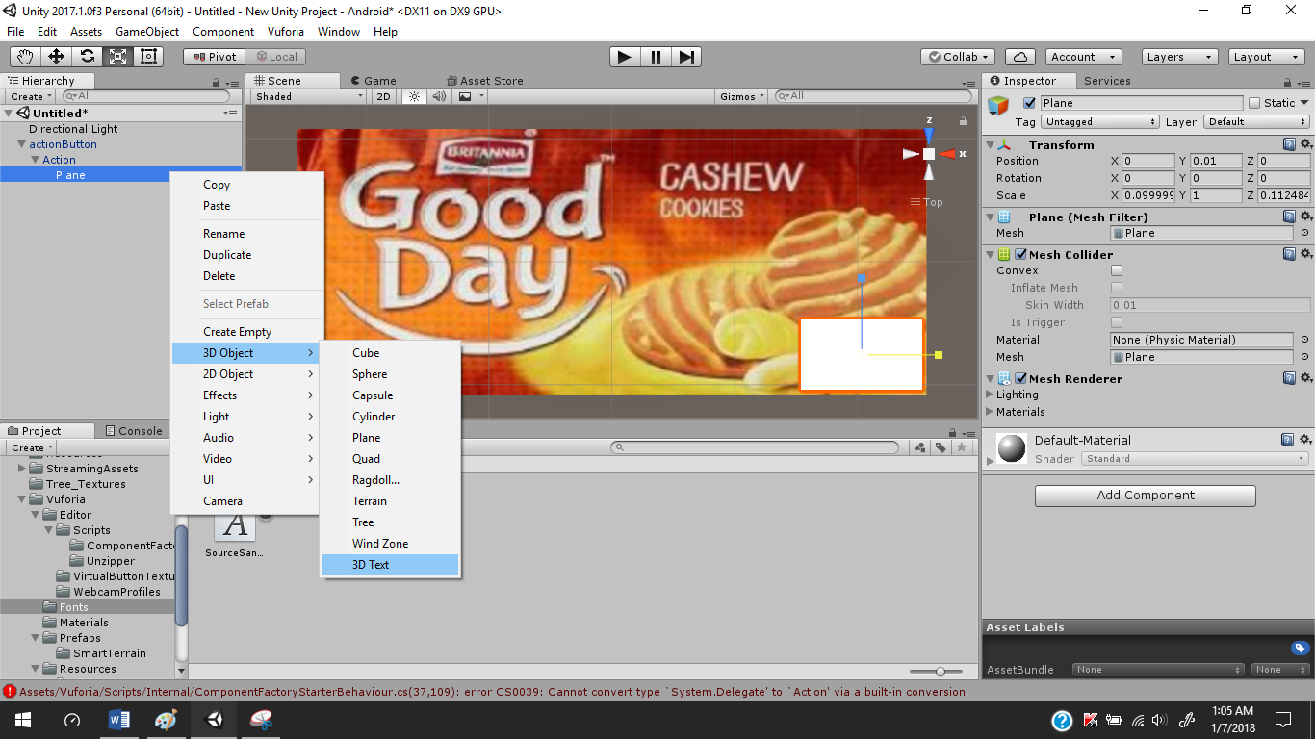  
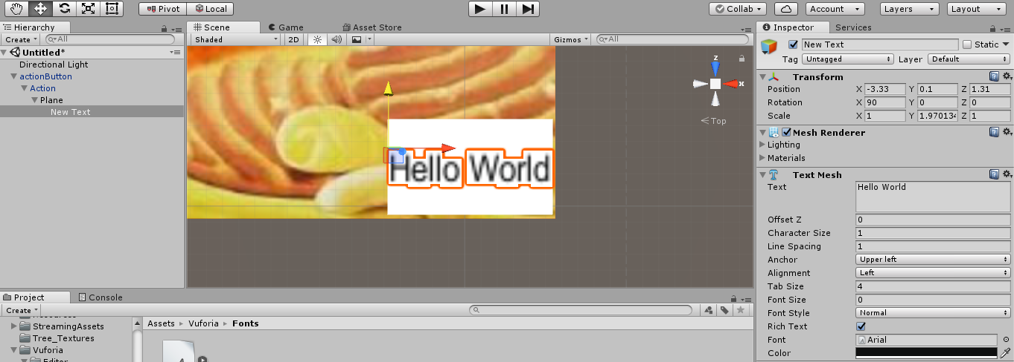  
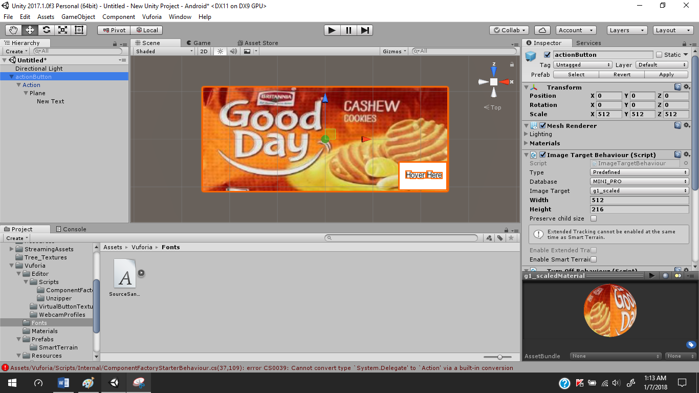  
Click on ‘File’  
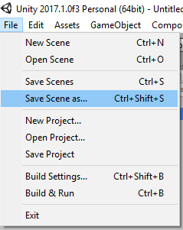  
Choose ‘Save Scene As’  
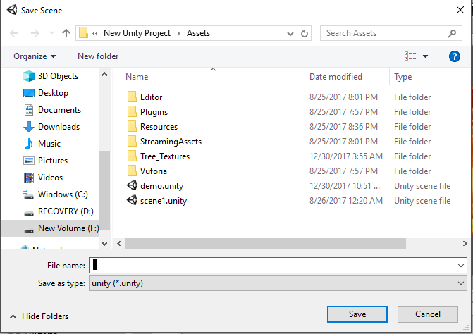

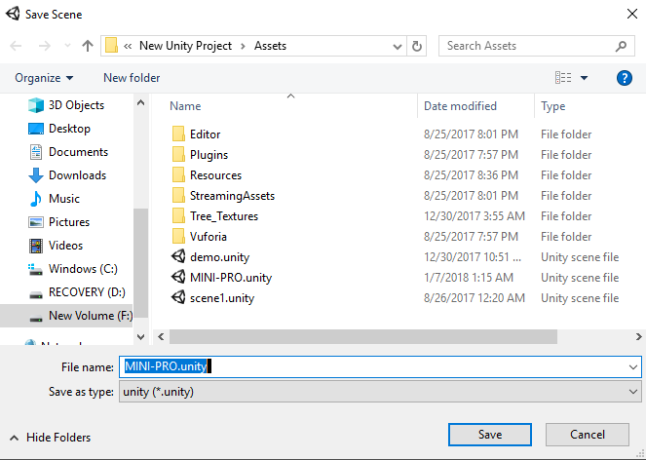  
  
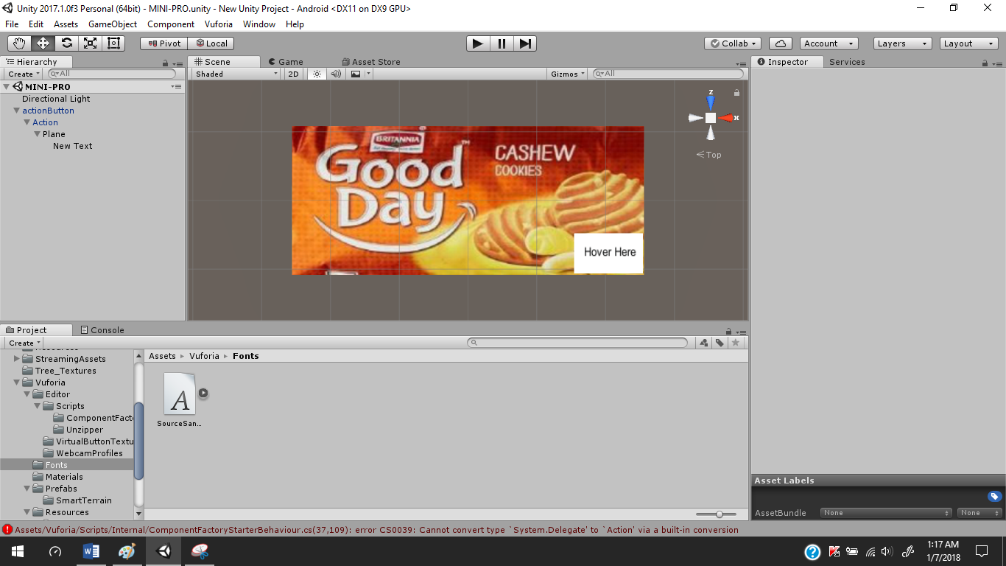

5.3)Transforming the Unity app to android.  
Connect the android phone to pc and choose the ‘Transfer Files’ option on your phone  
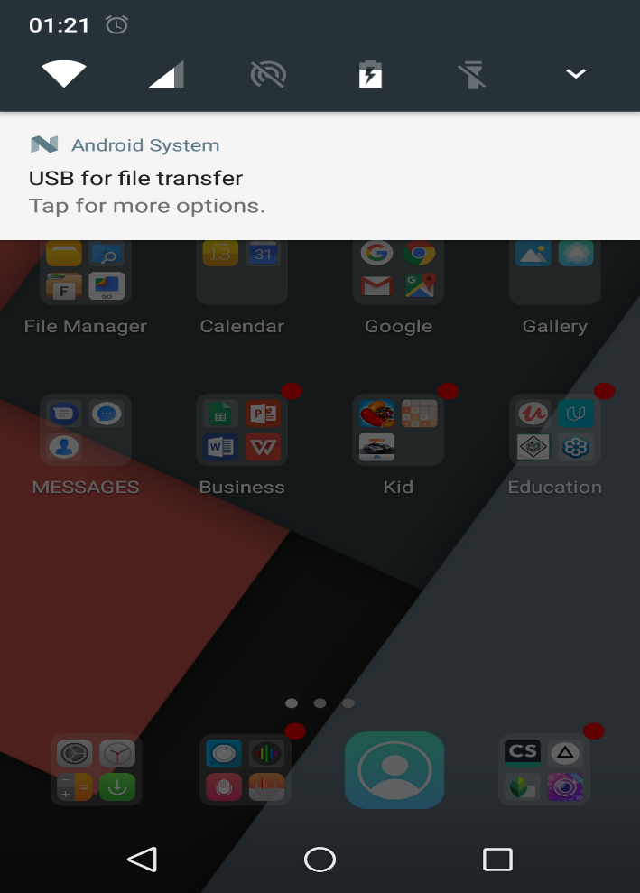  
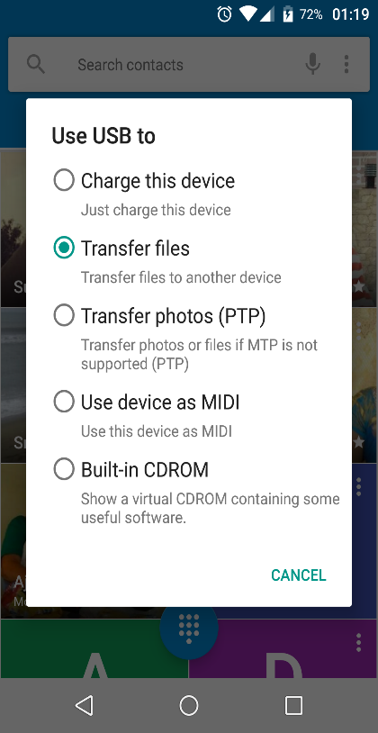  
Then in the Unity editor go to  
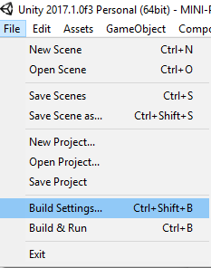  
This opens   
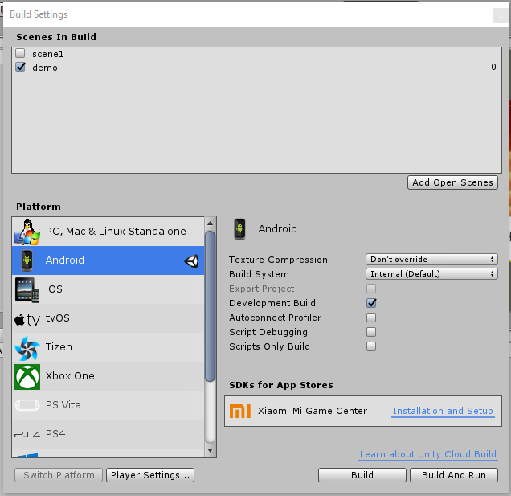  
Click on the ‘Player Setting’ and move to ‘Inspector’ tab.  
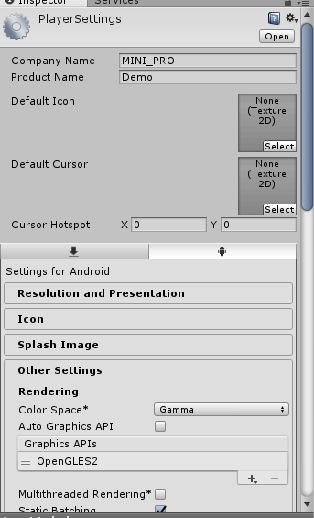  
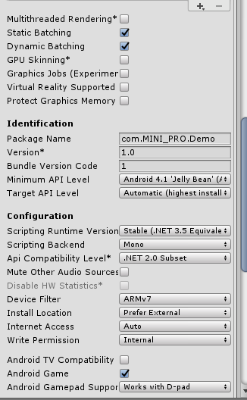  
Save and build again ,Let the app named as ‘Apps’.Then  
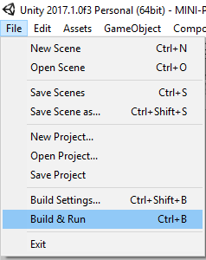  
This will install the app in to our phone.

5.4) Creating a website.  
There are many ways to create a website which is mainly used to show the information as the app scan correct Image Target. Thus the Final output is the web page that is displayed but it first needs to be deployed peoperly. The code of the webpage can be given in the CODE Section of Document.  
5.6) Deployment of Website.  
Go to XAMPP Installation folder then click on ‘xampp-control.exe’ to show the control panel of xampp.  
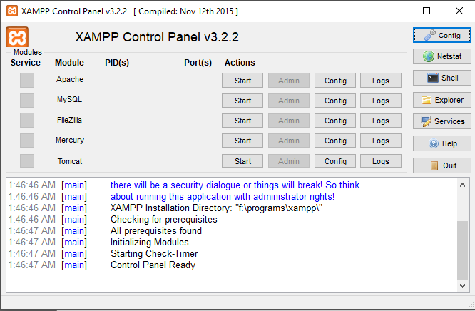  
Then click on ‘Tomcat’ which starts the server we can check the connection port by clicking on ‘config’ and then select’servers.xml’ search for ‘connection-port’. For my system it was 8083  
Now open a browser and log on to the server.  
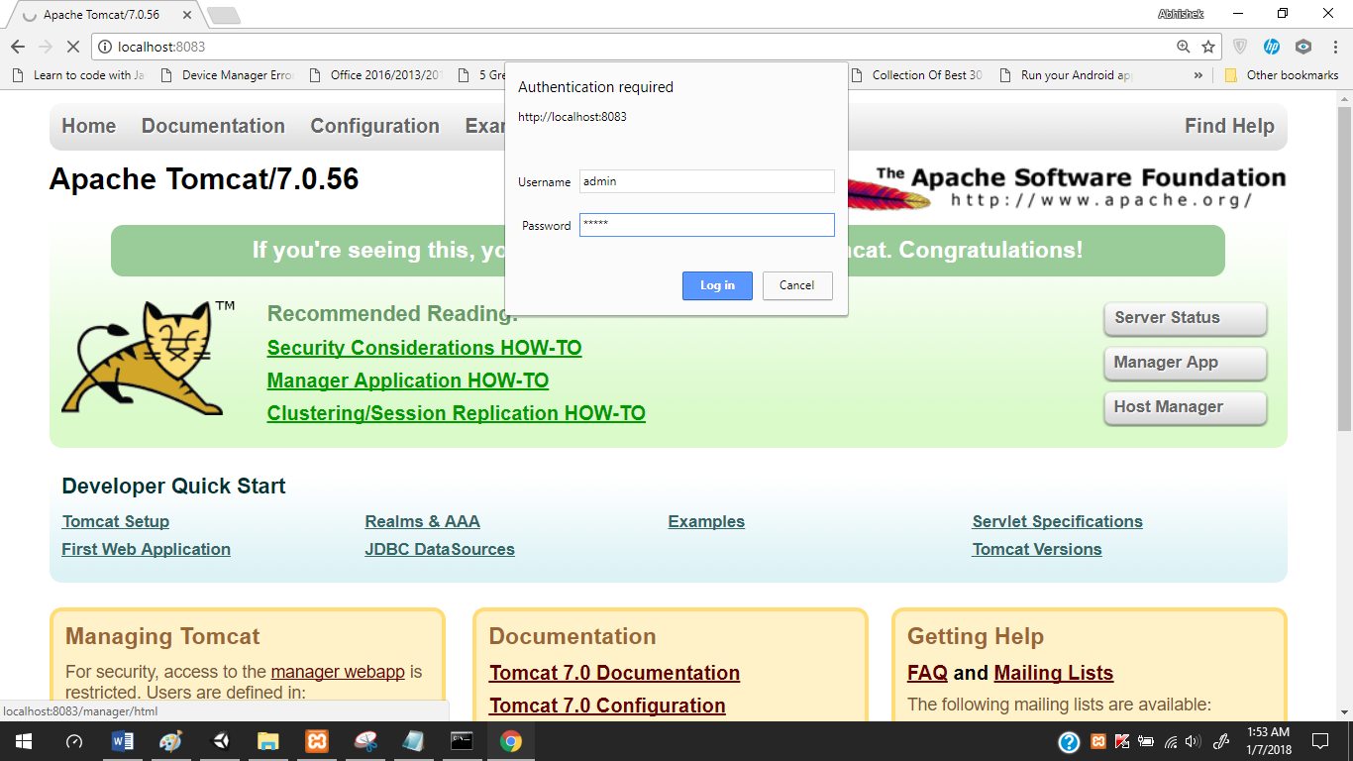  
when we login we see  
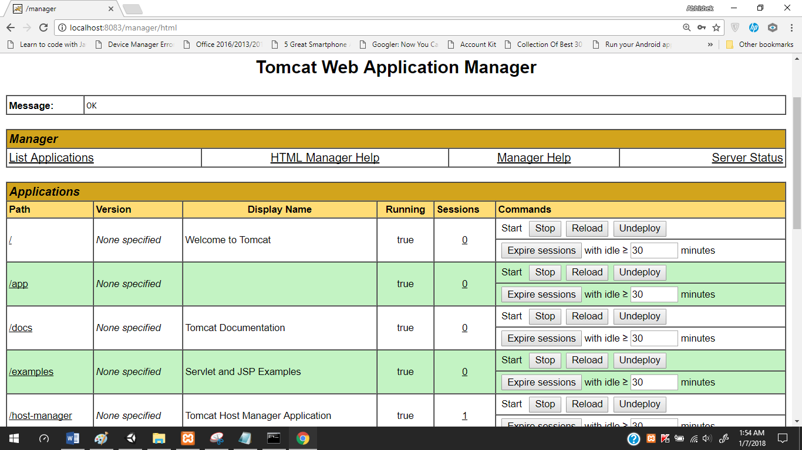  
list of projects here.  
Now let us add the files of our webpages to   
xmapp_installation_folder > tomcat > web-apps > paste the whole website here.  
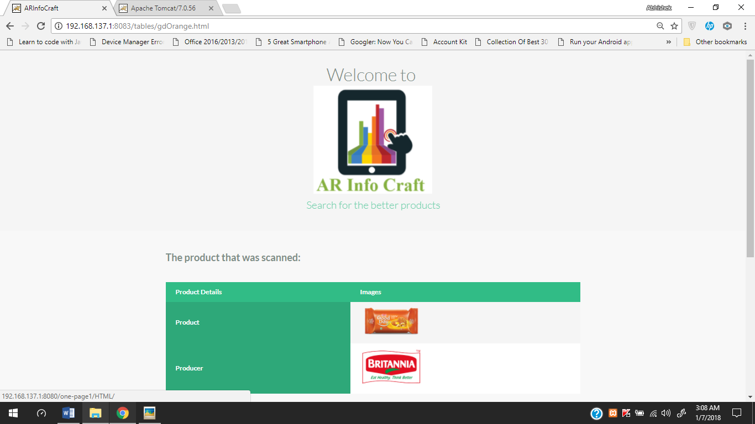

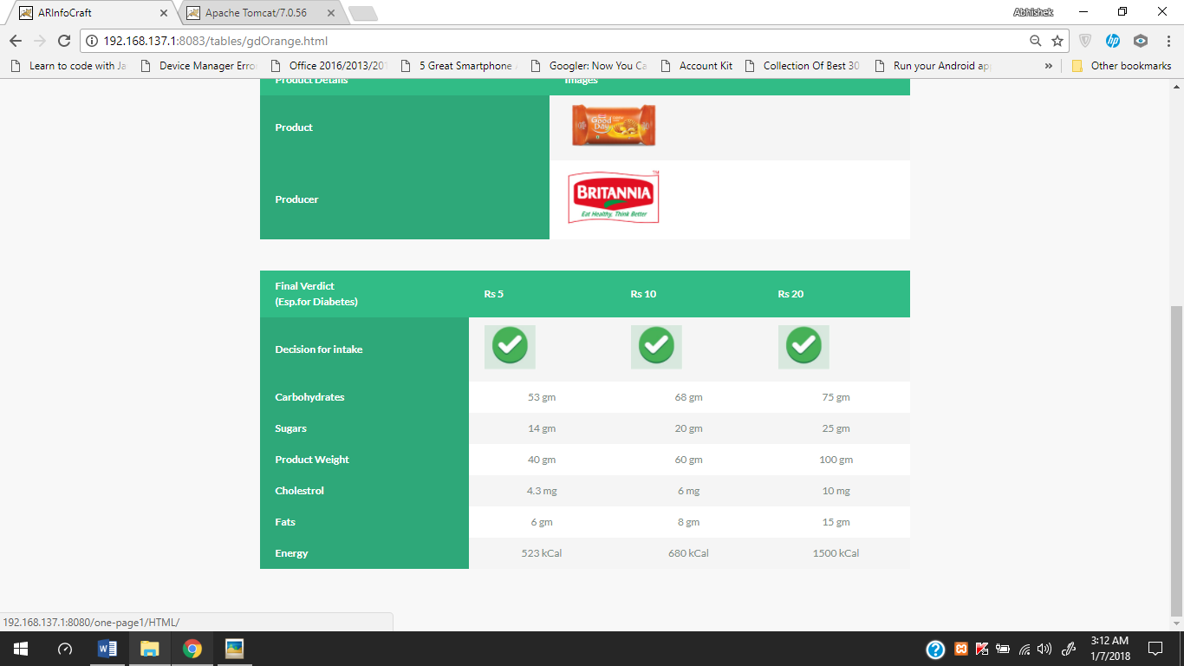

### 6.SYSTEM DESIGN / UML DIAGRAMS

### USE CASE DIAGRAM

### CLASS DIAGRAM

### 

### INTERACTION DIAGRAM

**7 CODE TEMPLATES.**

**CODE FOR THE WEBPAGES.**<!DOCTYPE html>

<html lang="en" class="no-js">

<head>

<meta charset="UTF-8" />

<meta http-equiv="X-UA-Compatible" content="IE=edge,chrome=1">

<meta name="viewport" content="width=device-width, initial-scale=1.0">

<title>ARInfoCraft</title>

<meta name="description" content="Sticky Table Headers Revisited: Creating functional and flexible sticky table headers" />

<meta name="keywords" content="Sticky Table Headers Revisited" />

<meta name="author" content="Codrops" />

<link rel="shortcut icon" href="../favicon.ico">

<link rel="stylesheet" type="text/css" href="css/normalize.css" />

<link rel="stylesheet" type="text/css" href="css/demo.css" />

<link rel="stylesheet" type="text/css" href="css/component.css" />

<!--[if IE]>

<script src="http://html5shiv.googlecode.com/svn/trunk/html5.js"></script>

<![endif]-->

</head>

<body style="align-self: center;">

<div class="container">

<header>

<h1>Welcome to <br><a href="http://192.168.137.1:8080/one-page1/HTML/"><img src="logo.png"><span>Search for the better products</span></h1>

</header>

<div class="component">

<h2>The product that was scanned:</h2>

<table>

<thead>

<tr>

<th>Product Details</th>

<th>Images</th>

</tr>

</thead>

<tbody>

<tr>

<th>Product</th>

<td><a href="http://britannia.co.in/products/good-day/butter"><img src="goodday-butter.png" width="150px" /></a></td>

</tr>

<tr>

<th>Producer</th>

<td><a href="http://britannia.co.in/"><img src="britannia-logo.png" width="150px" /></a></td>

</tr>

</tbody>

</table>

<table>

<thead>

<tr>

<th>Final Verdict<br>(Esp.for Diabetes)</th>

<th>Rs 5</th>

<th>Rs 10</th>

<th>Rs 20</th>

</tr>

</thead>

<tbody>

<tr>

<th>Decision for intake</th>

<td><img src="correct.png" width="80px";"></td>

<td><img src="correct.png" width="80px"></td>

<td><img src="correct.png" width="80px"></td>

</tr>

<tr>

<th>Carbohydrates</th>

<td style="text-align: center;">67gm</td>

<td style="text-align: center;">78gm</td>

<td style="text-align: center;">85gm</td>

</tr>

<tr>

<th>Sugars</th>

<td style="text-align: center;">20gm</td>

<td style="text-align: center;">22gm</td>

<td style="text-align: center;">30gm</td>

</tr>

<tr>

<th>Product Weight</th>

<td style="text-align: center;">40gm</td>

<td style="text-align: center;">60gm</td>

<td style="text-align: center;">100gm</td>

</tr>

<tr>

<th>Cholestrol</th>

<td style="text-align: center;">6.5 mg</td>

<td style="text-align: center;">7.8 mg</td>

<td style="text-align: center;">8 mg</td>

</tr>

<tr>

<th>Fats</th>

<td style="text-align: center;">11gm</td>

<td style="text-align: center;">22gm</td>

<td style="text-align: center;">35gm</td>

</tr>

<tr>

<th>Energy</th>

<td style="text-align: center;">494 kCal</td>

<td style="text-align: center;">544 kCal</td>

<td style="text-align: center;">800 kCal</td>

</tr>

</tbody>

</table>

</section>

</div><!-- /container -->

<script src="http://ajax.googleapis.com/ajax/libs/jquery/1/jquery.min.js"></script>

<script src="http://cdnjs.cloudflare.com/ajax/libs/jquery-throttle-debounce/1.1/jquery.ba-throttle-debounce.min.js"></script>

<script src="js/jquery.stickyheader.js"></script>

</body>

</html>

**Code Used in the Script.**

using System.Collections;

using System.Collections.Generic;

using UnityEngine;

using Vuforia;

public class gdBlue : MonoBehaviour,IVirtualButtonEventHandler {

public GameObject g;

// Use this for initialization

void Start () {

g = GameObject.Find ("actionButton1");

g.GetComponent<VirtualButtonAbstractBehaviour> ().RegisterEventHandler (this);

}

public void OnButtonPressed(VirtualButtonAbstractBehaviour vb)

{

}

public void OnButtonReleased(VirtualButtonAbstractBehaviour vb)

{

Application.OpenURL ("http://192.168.137.1:8080/tables/gdBlue.html");

}

}

**8.OUTPUT SCREEN**

1.  
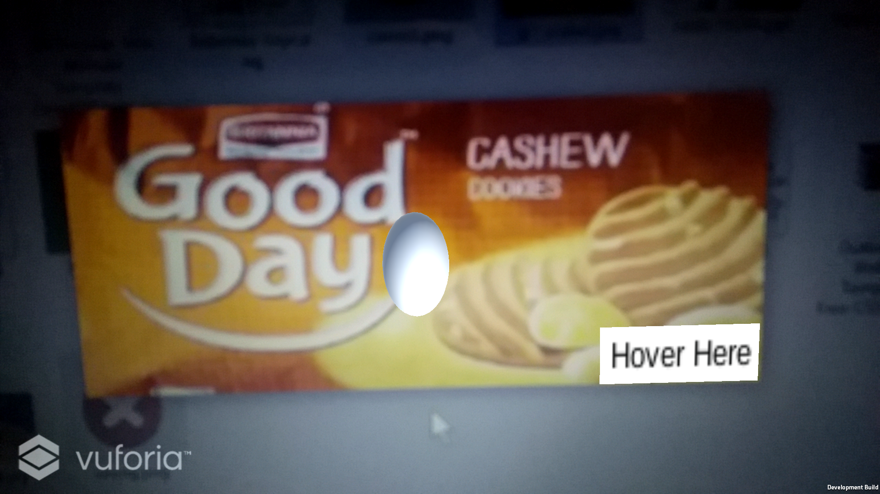  
2.

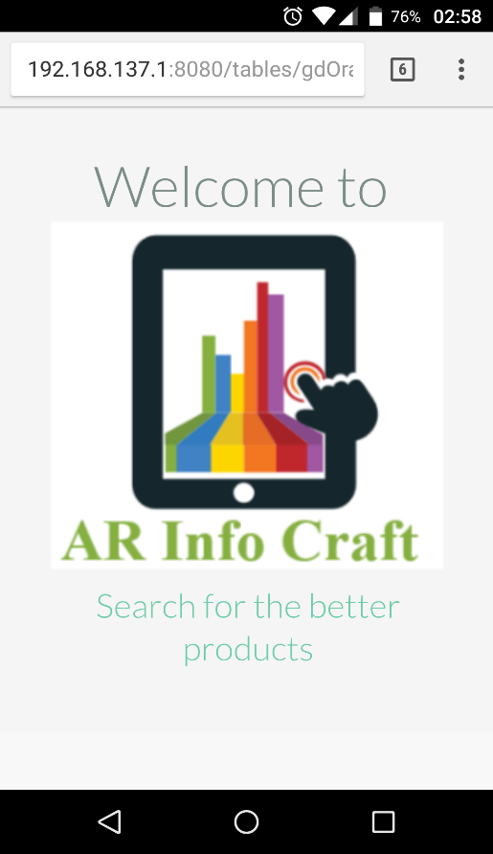  
ddfdfdfdf  
  
sdsdsdsdsd

2.

3.  
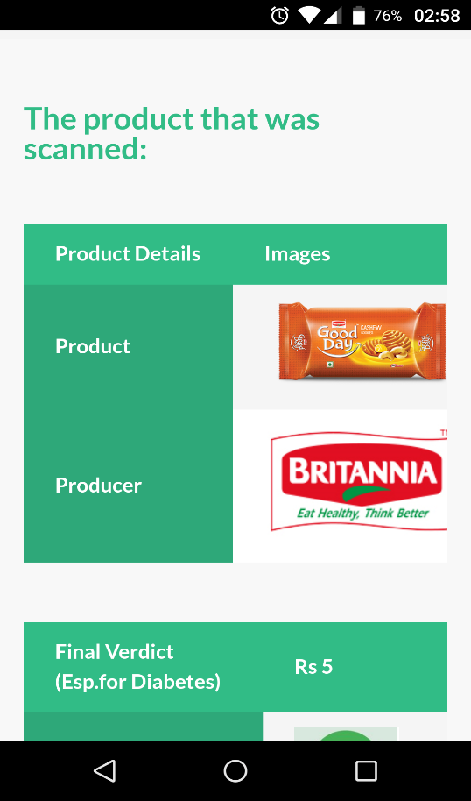

4.  
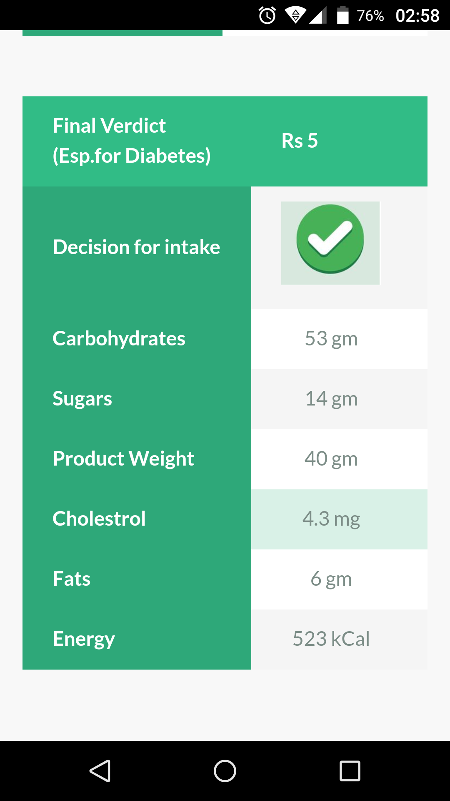

**9.ONLINE REFERENCE’S:**

ANDROID SDK: <https://developer.android.com/studio/index.html>

DIABETES CANADA: <http://www.diabetes.ca/about-diabetes/types-of-diabetes>

JAVA SDK: <http://www.oracle.com/technetwork/java/javase/downloads/jdk8-downloads-2133151.html>

UNITY-REQUIREMENTS: <https://unity3d.com/unity/system-requirements>

UNITY-INSTALLATION- <https://store.unity.com/download?ref=personal>

VUFORIA: <https://developer.vuforia.com/>

WAMP: <http://www.wampserver.com/en/>

XAMPP: <https://www.apachefriends.org/index.html>

YOUTUBE TUTORIALS ON UNITY: